### **Section for Research Paper: Analysis of Mentor Impact Using ANOVA**

#### **1. Introduction**

The mentor system in educational institutions is often implemented to provide guidance and support to students. However, the actual impact of assigned mentors on student performance remains an open question. This study investigates whether mentor assignments influence student outcomes in terms of **attendance, theory marks, and practical marks**. Given that mentors are assigned randomly, any significant differences in student performance should indicate a meaningful impact of mentorship, while a lack of significant variation would suggest otherwise.

To test this, we use **One-Way ANOVA (Analysis of Variance)**, which compares the means of student performance metrics across different mentors. If the **p-value** from ANOVA is less than **0.05**, it indicates a statistically significant difference, suggesting that the mentor assignment does influence student performance.

#### **2. Methodology**

The dataset consists of student performance metrics from two semesters, where each student has a randomly assigned mentor. The following steps were performed:

1. **Compute Average Metrics:**
   * **Average Attendance**: Mean attendance across all subjects in the semester.
   * **Average Theory Marks**: Mean of all theory subject scores.
   * **Average Practical Marks**: Mean of all practical subject scores.
2. **Perform One-Way ANOVA** to test whether mentor assignment has a significant impact on these metrics.
3. **Interpret Results** based on p-values and visualize distributions using boxplots.

#### 

#### 

#### 

#### 

#### 

#### 

#### 

#### 

#### 

#### 

#### **3. Results and Discussion**

##### **Semester 1 Results**

| **Metric** | **p-value** | **Interpretation** |
| --- | --- | --- |
| Attendance | 0.696 | No significant effect |
| Theory Marks | 0.056 | Weak, but not significant effect |
| Practical Marks | 0.728 | No significant effect |

For Semester 1, the p-values for attendance and practical marks are **well above 0.05**, suggesting that mentor assignment does not impact these metrics. Theory marks exhibit a p-value of **0.056**, which is close to significance but still does not meet the threshold, indicating only a weak potential effect.

##### **Semester 2 Results**

| **Metric** | **p-value** | **Interpretation** |
| --- | --- | --- |
| Attendance | 0.217 | No significant effect |
| Theory Marks | 0.129 | No significant effect |
| Practical Marks | **0.015** | **Significant effect** |

For Semester 2, both **attendance and theory marks show no significant mentor effect**. However, practical marks have a **p-value of 0.015**, which is **below 0.05**, indicating that mentor assignment has a **statistically significant impact** on practical performance. This suggests that some mentors may be more actively involved in practical sessions or that different mentors grade practical work with varying levels of leniency.

**Semester 1 Box-Plots**

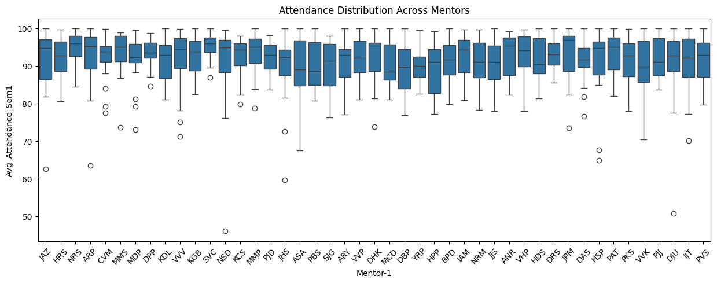

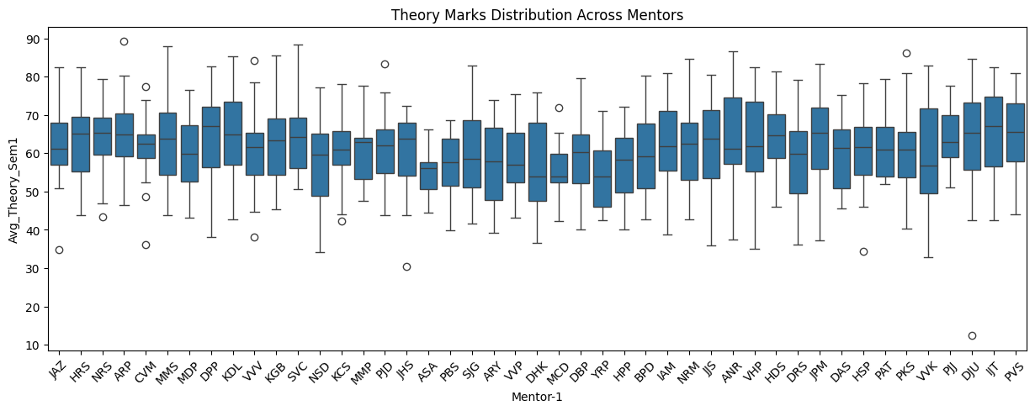

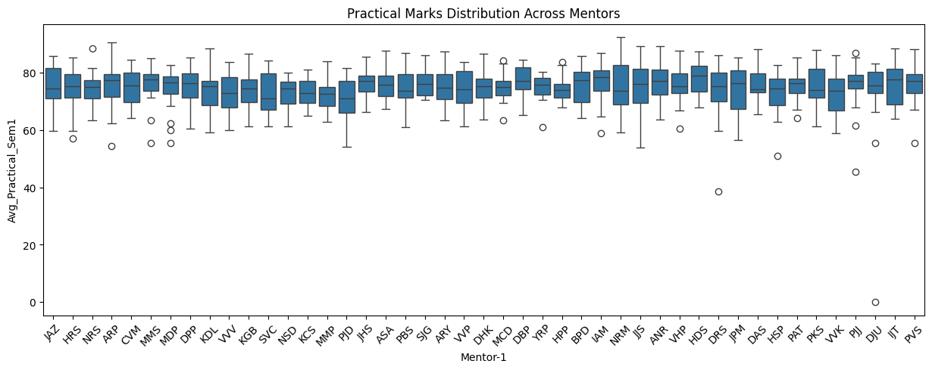

**Semester 2 Box-Plots**

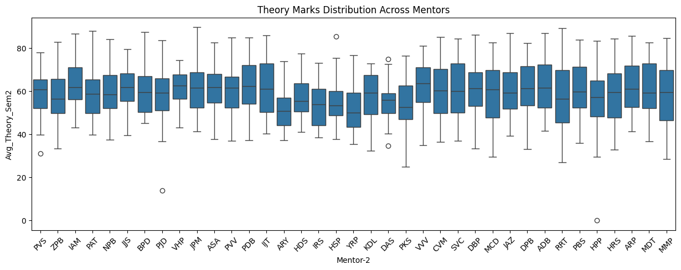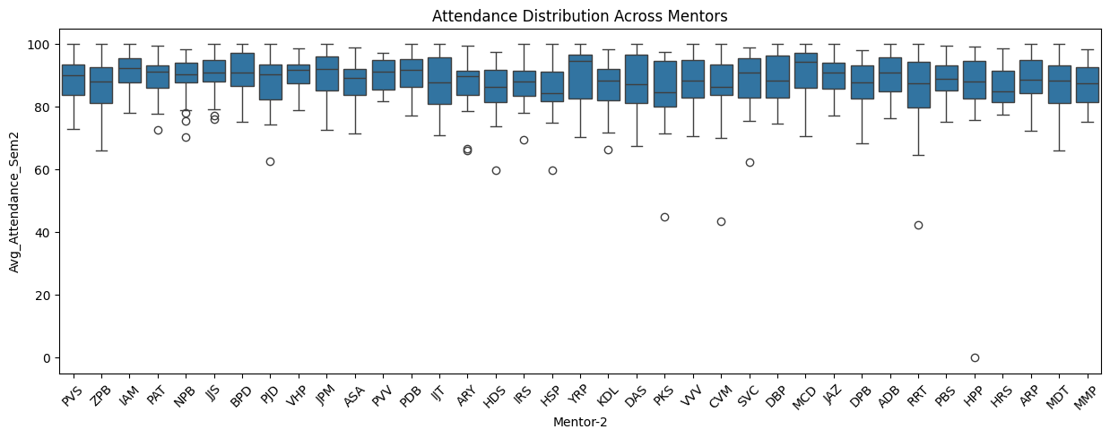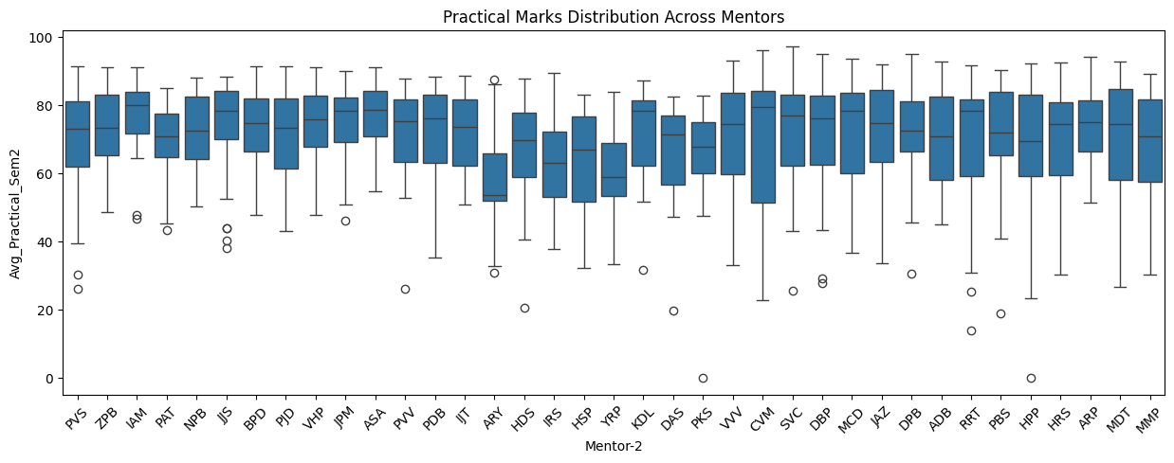

#### 

#### 

#### **4. Conclusion**

The results suggest that **mentor assignment has no statistically significant impact on attendance or theory marks**. However, **practical marks in Semester 2 show a significant mentor effect**, potentially indicating variations in mentor engagement or grading patterns for practical work. Further investigation using **post-hoc tests** (such as Tukey’s HSD) could help identify which mentors exhibit significantly different practical score distributions.

### **Analysis of Mentor Influence on Student Performance**

The results of the ANOVA analysis indicate that **mentor assignment had no statistically significant impact on attendance, theory marks, or practical marks in Semester 1**. The p-values for attendance (**p = 0.696**), theory marks (**p = 0.056**), and practical marks (**p = 0.728**) suggest that there is no meaningful difference in student performance based on mentor assignment.

In **Semester 2**, the ANOVA results similarly show **no significant effect of mentor assignment on attendance (p = 0.217) and theory marks (p = 0.129)**. However, practical marks exhibit a statistically significant difference (**p = 0.015**). Given that no such effect was observed in **Semester 1** and that the difference is only present in one metric (practical marks), this result is likely due to **random variation rather than a true mentor influence**.